MedVoice Biotech

App Requirements Specification

Alva Dynamics LLC
November 6, 2015

1. Introduction

1.1. Purpose
The main objective of this project is to develop a mobile app that is a self-diagnosis of health issues one may have.

  - Scope
The Software

  - Definitions, acronyms, and abbreviations

  - References:
[1] IEEE Recommended Practice for Software Requirements Specifications Software Engineering Standards Committee of the IEEE Computer Society. 1998.

  - Overview:
The rest of this document will have two major sections and Appendixes and will be ended with an index for the SRS documents [1]. The second section will contain all the product outlines, perspective, function, interface, and user characteristics. The third section will include the some specific requirements (e.g. hardware requirements).

- Overall description

This project will provide smartphone users an app that will help them identify possible medical conditions through pulse waveform and sound waves while linking advisory support to users.

  - Product Perspective

    - System Interfaces
The interface for this software is a mobile app both on iOS and Android.

    - User Interfaces
The user interface is a mobile app both on iOS and Android.

    - Hardware interfaces
The hardware used is the users’ mobile phones – either iOS or Android device.

    - Software interfaces
iOS and Android devices with a TBD minimum firmware version.

    - Communication interfaces
Wireless communication as well as HTTPS for security. VoIP communication will be used when entering a voice chat.

    - Memory constraints
Memory constraints will essentially be the size of the app being downloaded to the device. Everything else within the app will be miniscule in comparison.

    - Operations
The app will be operated from execution until full on exiting. It will still operate in background if the app isn’t terminated.

    - Site adaptation requirements
N/A

  - Product functions
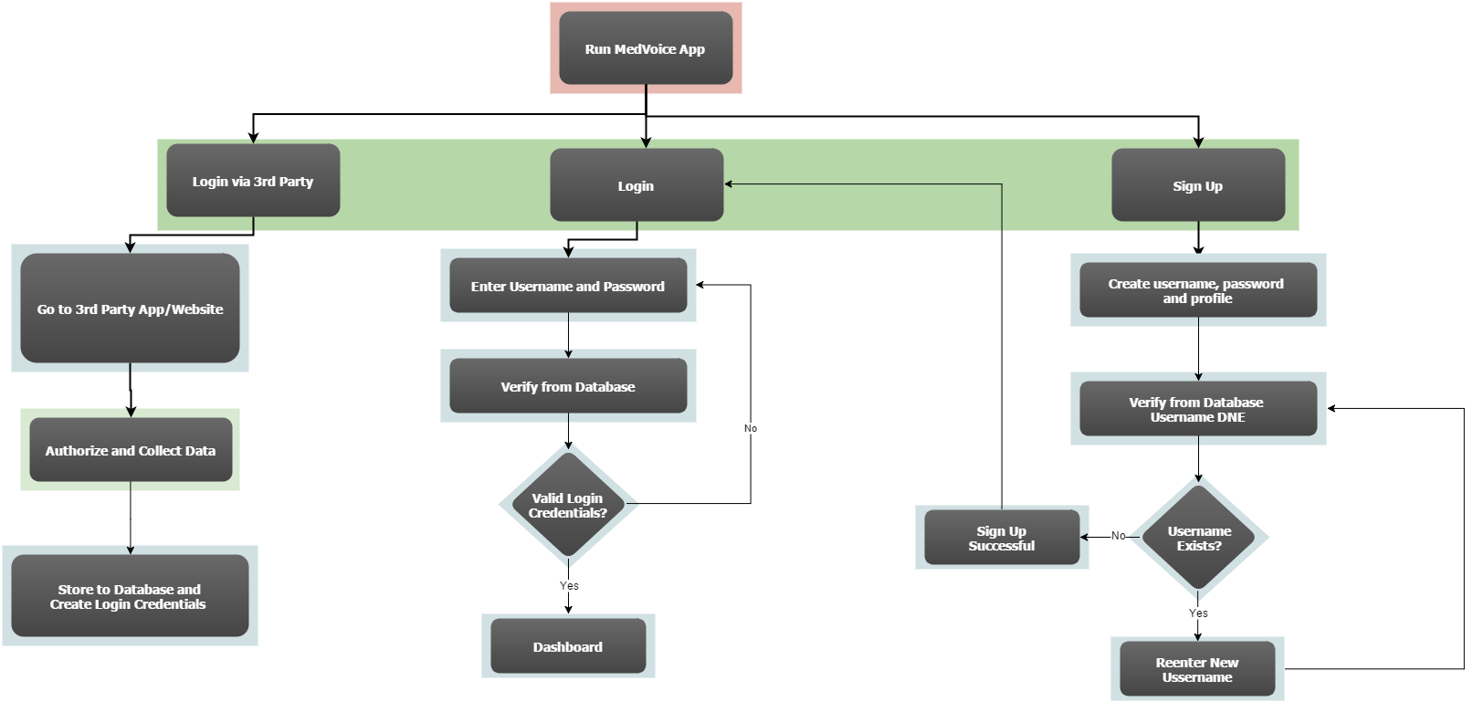

Figure 1. Sequence Diagram – Flowchart for Login/Sign Up Activity
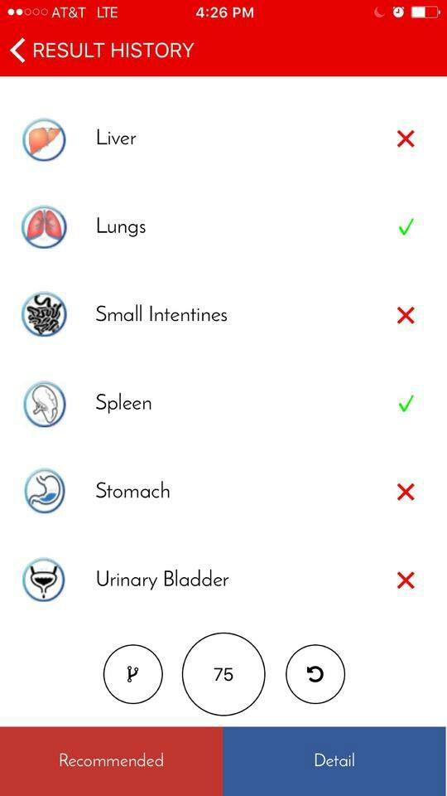
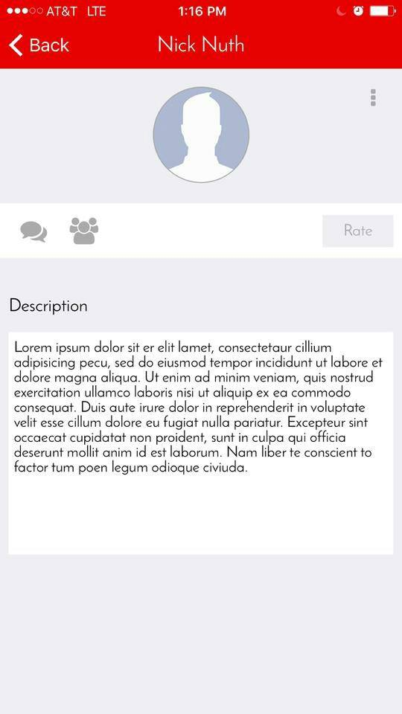
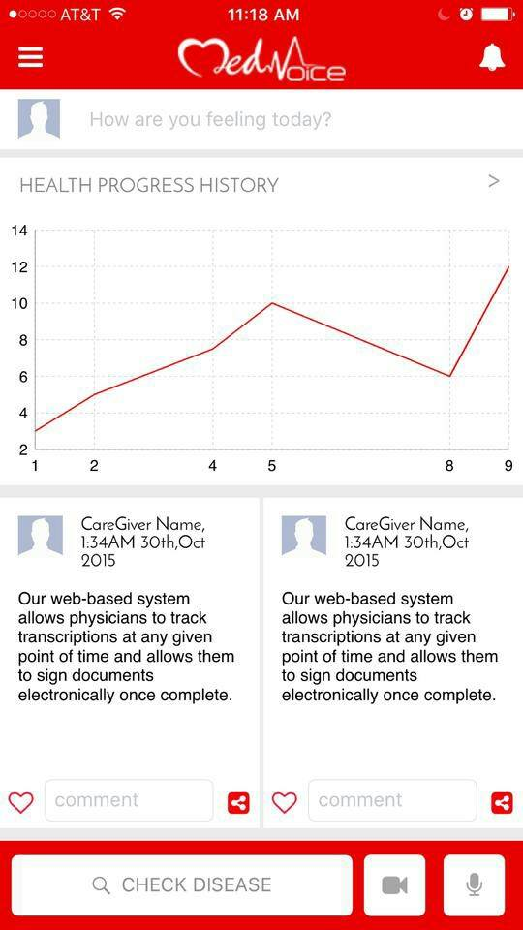

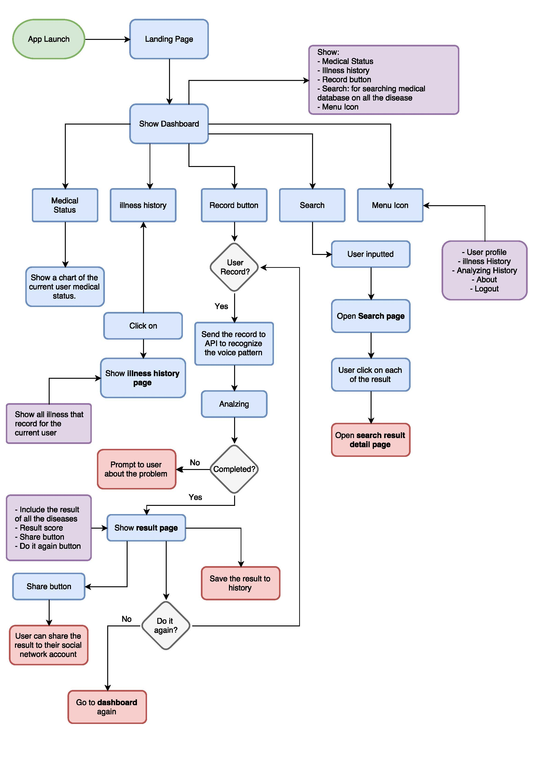
  - User characteristics
The app will be used by nurses, practitioners, doctors, caregivers and careclients worldwide to form a pier to pier network that expands beyond one’s local network.

  - Constraints
System should be able to handle multiple logins and activity processing simultaneously without any delays or errors. Same goes for processing payments, whether it’s done through the Google Playstore, Apple Store, or a third party online vendor account such as PayPal.

  - Assumptions and dependencies
Since we are using Adobe PhoneGap to turn our files into a mobile application, there are default minimum version requirements per mobile operating system. According to Adobe, all Android versions prior to 2.5.0 have been deprecated and 3.1.0 is the default version it is set to. We may also go into the apk and change those minimum version requirements, but that is out of our scope.

  - Apportioning of requirements
TBD

- Specific requirements

  - External interface
The external interface here would be HTML calls to the database to either retrieve or query information. Facebook will also become an external interface as the app will cross-communicate with it to retrieve user information.

  - Functions
Functions of the app and database would be reading/writing to the database and access to some of that information to admins.

  - Performance requirements
Multiple users will be able to access the database and send/retrieve information in a timely manner.

  - Logical database requirements
Users will be able to push their contact information through to the database either via entering it in themselves or by a Facebook login and information retrieval.

  - Design compliance
The app must comply with the database standards and be able to Create/Read/Update/Delete data.

  - Software system attributes

    - Reliability
The database will perform efficiently with fast access to sending and retrieving data even with multiple users.

    - Availability
Database will be available around the clock.

    - Security
Preliminary security measures will include a signup/login mechanism with user account’s kept private. This will all be included in the database’s security features on how they encrypt the data.

    - Maintainability
The data will be organized efficiently across a proper amount of tables so that correlation will be easier.

    - Portability
The database will be available to both iOS and Android devices of a minimum TBD firmware version or later.

  - Organizing the specific requirements

    - System mode
Modes of operation for the database, which would realistically be ON 24/7.

    - User class
Users will only be able to send data to the database, while the database will correlate said data and send said data back to the app. Users will not be able to have direct access to said data, unless they are admins.

    - Objects
Caregivers and Careclients

    - Feature
The database will feature Create/Read/Update/Delete functions.

    - Stimulus
User input inside the app

    - Response
Responses will include some sort of correlation of data patterns yet TBD.

    - Functional hierarchy
Flowchart for database again

  - Additional Comments
No additional comments.

- Support Information

4.4.1 Table of Contents and index

Table of Contents

Introduction.
1.1. Purpose.
1.2. Scope.
  - Definitions, acronyms, and abbreviations
  - References.
  - Overview.
- Overall description
  - Product Perspective.
    - System Interfaces.
    - User Interfaces.
    - Hardware interfaces.
    - Software interfaces.
    - Communication interfaces.
    - Memory constraints.
    - Operations.
  - Product functions.
  - User characteristics.
  - Constraints.
  - Assumptions and dependencies
  - Apportioning of requirements
- Specific requirements.
  - External interfaces.
  - Functions.
  - Performance requirements.
  - Logical database requirements.
  - Design compliance.
  - Software system attributes.
    - Reliability.
    - Availability.
    - Security.
    - Maintainability.
    - Portability.
  - Organizing the specific requirements.
    - System mode.
    - User Class.
    - Objects.
    - Feature.
    - Stimulus.
    - Response.
    - Functional hierarchy.
  - Additional comments.
- Supporting information:
  - Table of contents and index.

